Order Of Service

Singing: Psalm 150—CW page 122

Reading: Psalm 104:1-9

Opening Hymn: CW 367

Reading: Acts 20:17-28

Request Hymn: CW Supplement 749

Reading: Matthew 8:14-22

Sermon Hymn: CW 374

Sermon Text: Mark 8:1-13

Feeding Four Thousand

Prayer

The Apostles’ Creed, TLH page 12

Holy Communion

The Lord's Prayer

The Blessing

Closing Hymn: CW 327

* * * * * * * * * * *

Koinonia Hour
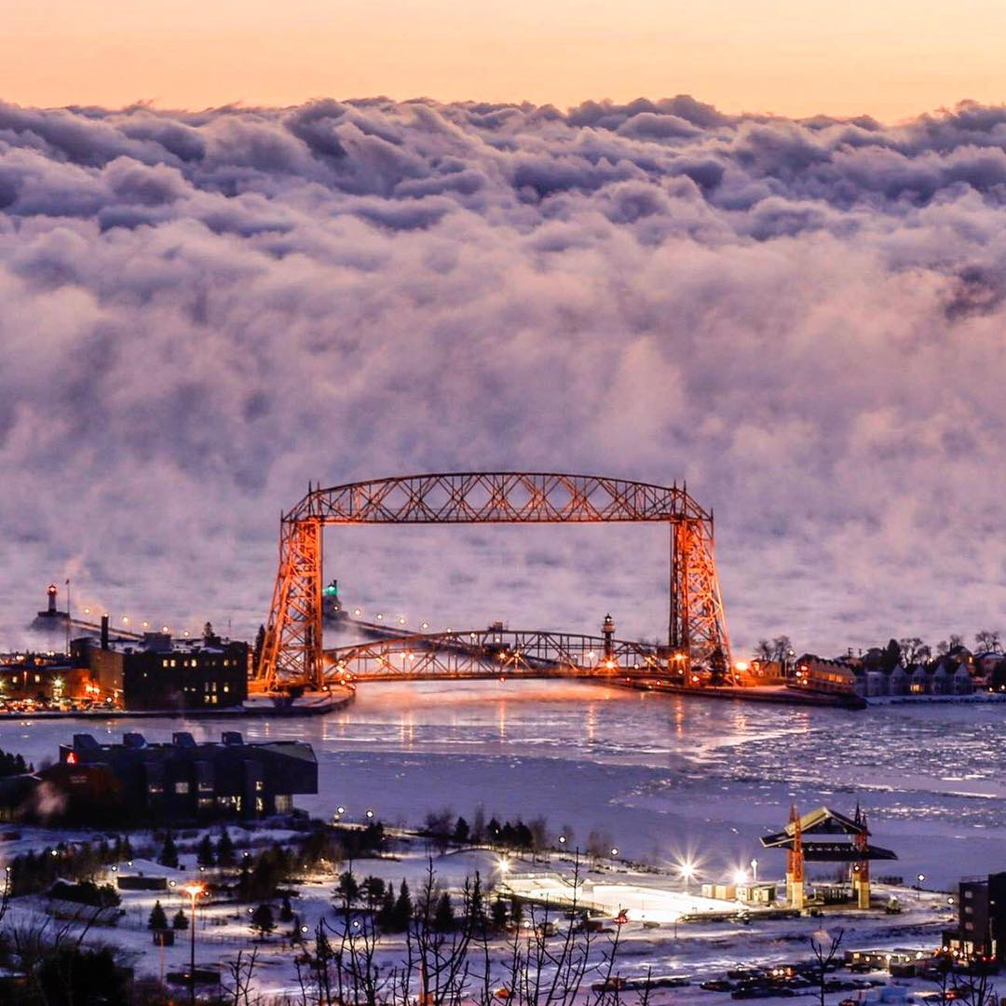

Duluth With Lake Clouds (Sea Smoke)

Water
Of
Life

7 July 2019

W A T E R O F L I F E

Independent Christian Church—Conservative Lutheran Doctrine

Worship Service: 9:30 a.m. Bible Study: 10:45 a.m.

Larry Cooper, Pastor E-Mail address:
111 N. Ridge Road lcooper@wateroflife.cc
Coon Valley, WI 54623 Web Site:
www.wateroflife.cc

* * * * * * * * * * * * * * * * * * * * * * * * * * *

Sermon Text: Mark 8:1-13

Feeding Four Thousand

* * * * * * * * * * * * * * * * * * * * * * * * * * *

Mark 8:1 In those days the multitude being very great, and having nothing to eat, Jesus called his disciples unto him, and saith unto them,
:2 I have compassion on the multitude, because they have now been with me three days, and have nothing to eat:
:3 And if I send them away fasting to their own houses, they will faint by the way: for divers of them came from far.
:4 And his disciples answered him, From whence can a man satisfy these men with bread here in the wilderness?
:5 And he asked them, How many loaves have ye? And they said, Seven.

Mark 8:6 And he commanded the people to sit down on the ground: and he took the seven loaves, and gave thanks, and brake, and gave to his disciples to set before them; and they did set them before the people.
:7 And they had a few small fishes: and he blessed, and commanded to set them also before them.
:8 So they did eat, and were filled: and they took up of the broken meat that was left seven baskets.
:9 And they that had eaten were about four thousand: and he sent them away.
:10 And straightway he entered into a ship with his disciples, and came into the parts of Dalmanutha.
:11 And the Pharisees came forth, and began to question with him, seeking of him a sign from heaven, tempting him.
:12 And he sighed deeply in his spirit, and saith, Why doth this generation seek after a sign? verily I say unto you, There shall no sign be given unto this generation.
:13 And he left them, and entering into the ship again departed to the other side.

